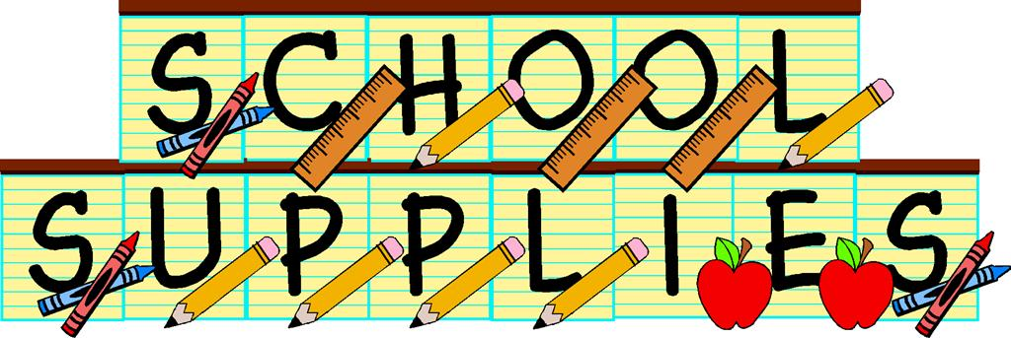

Napan Elementary

Grade K-5 School Supply List

2025-2026

* $60 fee for school supplies
* Indoor/Phys-Ed Sneakers (Please ensure Sneakers have skid-proof soles!) As well if your child is unable to tie, please send Velcro sneakers to help foster independence.
* Full –Size Book Bag
* Lunch Can
* 3 Boxes of Kleenex – We ask in February to replenish
* 1 Box of Large Ziplock Baggies
* 1 Box Sandwich Baggies
* Flip Top Water Bottle (Label with name please)
* (Grade K/1 – a change of clothes including shirt, pants, socks and undies in a LABELED ziplock bag. Please put labels on the clothing and the bag)